Advertising Feature
How to fry food, guilt free
We cannot escape celebrities promoting healthy eating, whenever we scroll on social media. Yet, according to government research, adult and child obesity is far from dissipating in the UK. The consumer obsession with personalities who chronicle their eating habits can be inspiring. However, what about the odd treat? Those days when a ‘no cook protein ball’, resembling a raw falafel, will not replace the profound joy of a bowl of warm chips doused in salt and vinegar?
Affordable air fryers are transforming eating habits. Busy households can cook their favourite meals quickly, without adding any oil; guilt free chips are finally possible, and they are delectable. From golden roast potatoes to a whole chicken, there are few things you cannot cook when you have the Ninja Air Fryer MAX AF10UK in your kitchen.
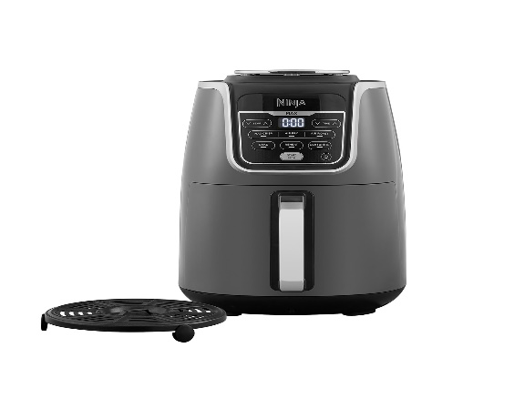
There are variety of air fryers on the market but the Ninja Air Fryer MAX AF10UK is great value, with a generous family-size 5.2L capacity, and it features six different cooking functions:
- Air fry
- Roast
- Reheat
- Bake
- Dehydrate
- Maximum Crisp

You can easily cook all your favourite dishes, seven days a week, safe in the knowledge you will not be adding fat to your diet. So, how does it work?
Air fryers circulate hot air around your food. The heat removes moisture, resulting in a crispy finish. You can enjoy succulent salmon fillets, and scrumptious chocolate brownies, baked to perfection. You can even reheat, cook from frozen, and even dehydrate fruit. With the rise in cost of living an air fryer will reduce your bills as more economical than cookers, and halves cooking time.
Oil free and fast cooking, that doesn’t compromise on texture or flavour, and allows us to indulge in guilt free treats, what’s not to like? Ninja Air Fryer MAX AF10UK

