**Top 30 Productivity Hacks to Get More Done in 2024**

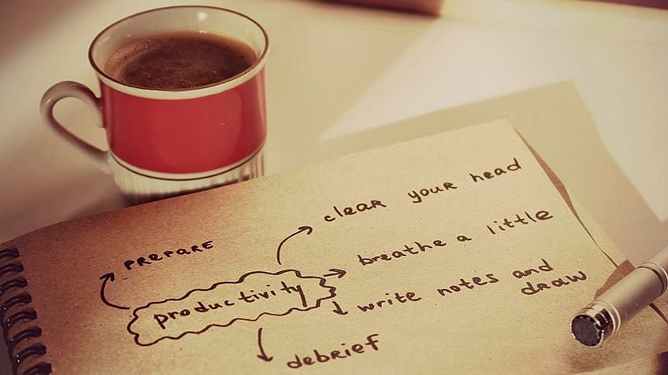

Are you struggling to stay on task? Do you ever feel a little incomplete at the end of your workday, feeling like you could've done more? Well, it doesn't have to be this way. You can leave work feeling euphoric and fulfilled with what you have accomplished. It takes a few productivity hacks to help you work more efficiently and, most importantly, leave you with more free moments every day.

What Is Productivity?

[Productivity](https://www.simplilearn.com/what-is-productivity-and-how-to-define-and-measure-it-article) is more than doing more things or ticking tasks off your to-do list. Productivity means only focusing on accomplishing important things. The road to being more productive can be long, so do not panic – take one positive step at a time.

The Importance of Being Productive

Your ability to be [productive](https://www.simplilearn.com/how-to-be-more-productive-article) can be one of the critical determinants of your professional success and personal happiness. Those who can consistently produce good quality output at a sustainable rate can advance in work and life.

Growth in productivity is an opportunity to increase output without increasing inputs and incurring allied costs. According to the [US Bureau of labour statistics](https://www.bls.gov/k12/productivity-101/content/why-is-productivity-important/home.htm), productivity growth has enabled the US business sector to produce nine times more goods and services since 1947 with a relatively less increase in hours worked.

Being productive can help you prioritize tasks, manage time and resources efficiently, and frees up time for more rewarding activities.

Top 30 Productivity Hacks to Maximize Productivity in 2024

1. Plan Your Day Ahead of Time

The first step to being productive is planning a day's schedule in advance. You should know what you're doing when you're doing it, and how long on any given day. Without a schedule, you're likely to miss out on important tasks.

Write down a detailed plan of the day early morning or the night before. Write everything you need to do so that you have a sense of direction and know what to focus on next. This eliminates all guesswork, and there's less chance of you drifting away and wasting time because you do not know what you'll do next.

2. Write Down the Three Most Important Daily Tasks

Jot down the three most important tasks for the day. Describe the tasks in detail to avoid any ambiguity. Focus on important tasks rather than urgent ones.

3. Use Any Productivity Technique

Supercharge your productivity by using a productivity method. An incredibly powerful productivity tool can help you stay focused during work time. A productivity system will help you manage your day by setting accomplishable goals. Select a productivity method that is right for you that helps you increase your daily output.

4. Set a Single Goal for Each Day

Set a single goal for each working day so you can focus on individual tasks. A good idea can be breaking down daily goals into multiple tasks, where you'll only tend to that particular task in the allotted time.

Become a Project Management Professional

* 6%Growth In Jobs of Project Management Profiles By 2024
* 22 million Jobs Estimated for Project Management Professionals By 2027

**PMP® Certification Training**

* + Access to Digital Materials from PMI
  + 12 Full-Length Simulation Test Papers (180 Questions Each)

[**View Program**](javascript:void(0))

Here's what learners are saying regarding our programs:

* Katrina Tanchoco

Katrina Tanchoco

Shell - Manila,

The interactive sessions make a huge difference as I'm able to ask for further clarifications. The training sessions are more engaging than the self-paced modules, it's easier now that I first decided to take up the online classroom training, and then followed it up with the self-paced learning (online and readings).

* Ralph Lauren Dorado 

Ralph Lauren Dorado

AECOM Philippines,

I find the course to be excellent in terms of content, structure the mode of presentation. The lessons are simplified in such a way that people who don't have background in project management will also be able to understand the course.

Not sure what you’re looking for? View

5. Set Specific Times to Check Email

Email checking accounts for one of the main distractions that wastes valuable time during the workday. Choose to check emails twice a day, preferably before lunch and before finishing the day's work.

6. Learn to Say “No”

Saying no can be hard for some, but if you want to [boost your productivity](https://www.simplilearn.com/ways-upskilling-will-cut-costs-boosts-productivity-article), you can't allow others to order you around every now and then.

7. Use Website Blockers

Use website blockers to stop distracting websites from popping up in the middle of your work.

8. Use red and blue colours more often

Remove clutter from your desk. Studies suggest that red and blue colours improve brain performance, with red known to increase attention to details while blue sparks creativity. Surround your workplace with these colours to enhance productivity.

9. Two-Minute Rule for Small Tasks

Do not waste time deciding whether you should do small tasks that keep cropping up throughout your day. Instead, ask yourself if you can complete the task in 2 minutes or less – if yes, go ahead with the task. If not, add the task to your to-do list for later.

10. Listen to Productive Music

Music is an excellent therapy to help maintain focus and stay productive. Choose music that enables you to focus on the task at hand.

11. Use Templates for Regular Tasks

Create templates for routine tasks that are created the same way every time. This will save you a lot of time and increase your overall productivity.

12. Group Similar Tasks

Batch similar tasks so you can complete them with the same frame of mind. This will make your work process flow smoothly and help you do more in less time.

13. Avoid Multitasking

It might be tempting to do two things simultaneously, but multitasking does more harm than good. Research shows that about 98% of people are less productive when they multitask as they are not focusing on a single task.

14. Use an Important/Urgent Matrix for Decision Making

An effective [time management](https://www.simplilearn.com/time-management-skills-article) tool called Important/Urgent Matrix or Eisenhower Matrix helps prioritize tasks on the basis of how important or urgent they are. The matrix divides tasks into four different quadrants - Important & Urgent, Important & not urgent, not important & urgent, not important & not urgent. This method ensures you spend your time effectively as well as efficiently.

15. Start Your Day with a Tough or Easy Task

The way you start your day dictates the flow of the rest of the day. You can either start by doing the most demanding task first, so everything else feels more effortless, or do the easiest thing first to gain valuable momentum.

16. Use the “One and Done” Rule

Most of us tend to keep some tasks aside, thinking of taking care of those tasks later. But rarely do we actually do those later because we won't add them to our to-do- lists. To avoid this, add each new task to a to-do list, so there's no risk of forgetting later.

17. Take Regular Breaks

Breaks give your mind a much-needed chance to recover from intense focus, but you must maximize the benefit of breaks. Zone out completely or meditate during breaks to relax your mind and body.

18. Create a Break Agenda

List everything you want to do on your break and squeeze these between work time. This will help accomplish tasks efficiently during work time. Thus, you'll wisely use your break time to do things you enjoy.

19. Work in Short Bursts

The human mind can concentrate on the same thing for a short span. So, it makes sense to work in short bursts like the Pomodoro technique, where you work in 25-minute sessions with 5-minute breaks in between. This helps motivate you to complete tasks in a short time.

20. Create a Dedicated Workspace

If you are [working from home](https://www.simplilearn.com/ten-years-of-change-in-the-workplace-article) or remotely, create a dedicated workspace where you'll go to work and leave once you're finished.

21. Work Near Natural Light

A simple productivity hack is to create your workspace near natural light. Exposure to sunlight is believed to improve sleep, thereby contributing to your well-being and productivity levels.

22. Eliminate Possible Distractions

It's easy to give in to distractions, but you must find ways to avoid distractions while working. Distractions cause a lot of wasted time trying to regain focus on the task. Getting rid of distractions can result in more productive work being done in lesser time.

23. Break Down Your Goals

Instead of procrastinating on your far-fetched ultimate [goals](https://www.simplilearn.com/time-management-skills-to-achieve-career-goals-article), break down the goals into smaller, more attainable goals that seem more realistic. These goals should be easy to accomplish and fit into your schedule.

24. Take Time to Reattach Yourself to Work Every Morning

Once you're finished with the day's work, you probably try to detach from work. Take a few minutes in the morning to reattach yourself to work by thinking about what you achieved the day before or what you hope to accomplish during the given day.

25. Wake Up Early

This can give you a great head start on any working day because you feel entirely re-energized at the beginning of a day. You can get a lot of work done early in the morning when there are fewer distractions than at midday.

26. Make Sure Every Task Is Related to a Goal

Before taking up a task, make sure it is related to a long-term goal like one of your SMART goals. If the task is unrelated to your advancement, either eliminate it or assign it to someone else.

27. Follow Deadlines

Regardless of how long you have to complete a task, make sure you do it in the given amount of time. Your productivity will improve if you know a deadline is approaching.

28. Schedule Time for Self-Care

Schedule self-care activities to recharge yourself to prevent burnout from work pressure. It could be anything that helps you relax and unwind — leisurely reading on your favourite couch, a relaxing bedtime ritual, a 10-minute walk, meditating, painting, or anything else.

29. Let Go of Perfectionism

Nothing is perfect, so don't waste time trying to make every task perfect. If the work is good enough, move on to the next thing.

30. Identify the ‘Why’ Behind Your Job

Ask yourself why you chose to go into the field that you did. Make sure to keep those reasons in your mind while working so you stay motivated to be productive and successful in your job.

To read more about productivity and time management, follow out what productivity is, [productivity tips](https://www.simplilearn.com/work-from-home-tips-article), and tools guide.

Here’s another hack to increase your productivity in 2024 - upskilling! Take the next step in your career by choosing from Simplilearn’s amazing PG and Master programs! Check out some popular PGP programs like [Lean Six Sigma](https://www.simplilearn.com/pgp-lean-six-sigma-certification-training-course), [Project Management](https://www.simplilearn.com/pgp-project-management-certification-training-course), and [Design Thinking and Innovation](https://www.simplilearn.com/ui-ux-certification-training-course) to help you get started!